13.85: There are many equivalent ways to find the period of this oscillation. Energy considerations give an elegant result. Using the force and torque equations, taking torques about the contact point, saves a few intermediate steps. Following the hint, take torques about the cylinder axis, with positive torques counterclockwise; the direction of positive rotation is then such that 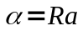, and the friction force f that causes this torque acts in the –x-direction. The equations to solve are then

Which are solved for

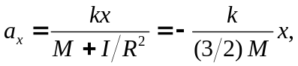

where 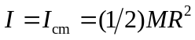 has been used for the combination of cylinders. Comparison with Eq. (13.8) gives 